CODE ALPHA
ASSIGNED TASK 3

Submitted By:
Syed Wajih Ul Hassan Naqvi
ID: CA/DF1/92245

Secure Coding Review Report
Application: Simple Login System

Introduction
This report reviews a simple C++ login application to identify common security vulnerabilities and recommend secure coding practices.

Source Code
The reviewed application accepts a username and password and compares them with hardcoded credentials.

Security Vulnerabilities Identified
- Hardcoded credentials (High)
- Plain text password handling (High)
- No input validation (Medium)
- Unlimited login attempts (Medium)

Static Analysis / Inspection Method
Manual code inspection was used. Tools such as Cppcheck and SonarQube can also be used for automated static analysis.

Recommendations and Best Practices
- Store credentials securely in a database or configuration.
- Hash passwords using bcrypt or SHA-256 with salt.
- Validate all user inputs.
- Limit login attempts.
- Follow least-privilege and secure authentication practices.

Remediation Steps
Replace hardcoded credentials, implement password hashing, validate inputs, and introduce account lockout after repeated failed logins.

Improved Secure Code and it’s Output
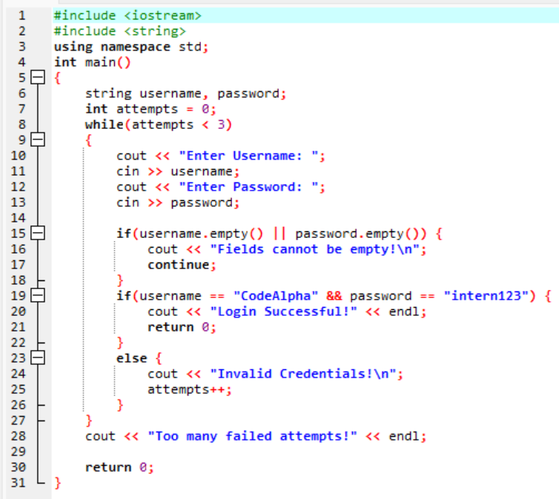
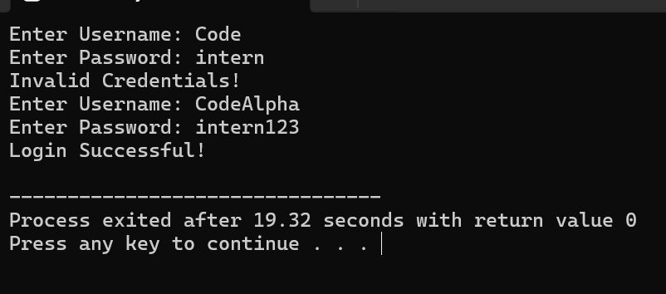
Here, if the login credentials are incorrect then the system asks the user to input them again or it won’t proceed.

Conclusion
The code review identified several security weaknesses in the login system, including hardcoded credentials, lack of input validation, and insecure password handling. By applying secure coding practices such as password hashing, validation, and login restrictions, the application can become significantly safer and more reliable.

-----------------------------------------------------

